

Department of Mechanical Engineering

EMCH 368
MECHATRONICS

Lab 02
Sensors

Last Edited: 01/08/2024 by J. Vaught
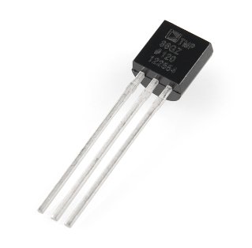
The TMP36 included in this Arduino kit is a temperature sensor. (CAUTION! The TMP36 looks similar to the BC547 transistors which look similar. Check the IC code on the device itself to verify.) This component outputs a voltage whose magnitude depends on the temperature it senses. It has three pins: one for ground, one for power, and a third that outputs the variable voltage to your Arduino. This sensor outputs voltage that changes directly proportional to degrees Celsius.

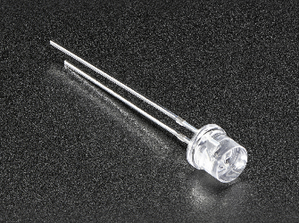
Phototransistors are components that generate a current proportional to the quantity of light they absorb. By connecting the positive end (identified by the longer leg) to the 5V power of the Arduino and the negative end (short end) to ground, you can measure the change in current by checking the voltage on the pin.

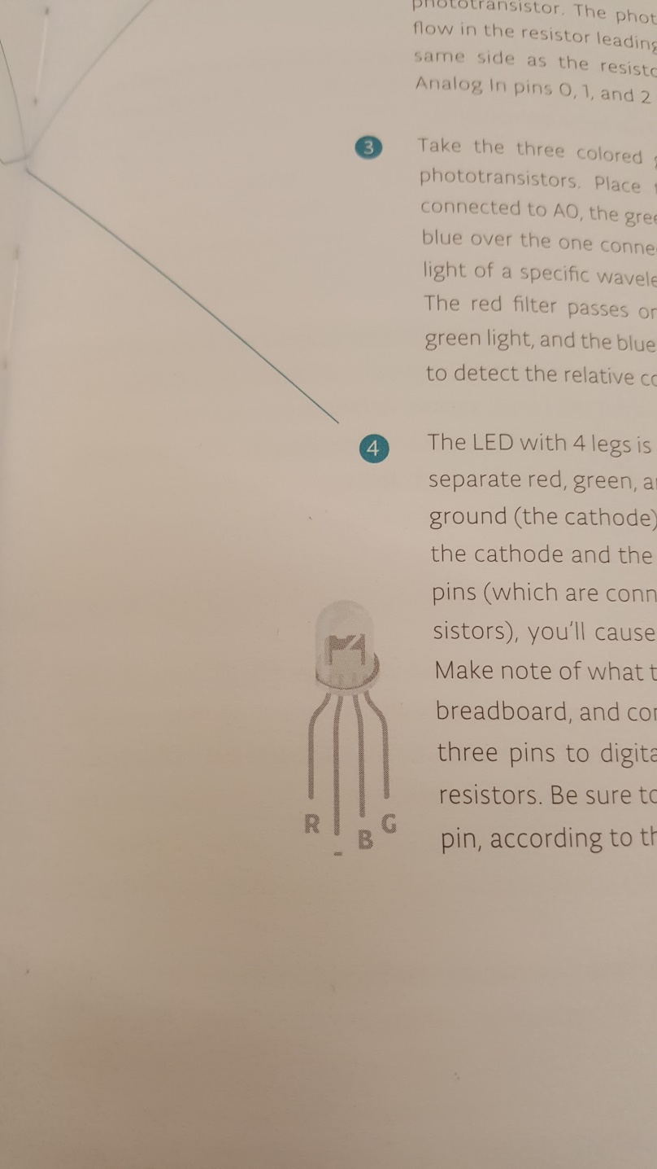
This LED with 4 legs is a common cathode RBG LED. The LED has separated red, green, and blue elements inside as well as a common ground leg. By varying the voltage between each color’s pin, the LED can output different amounts of light of each color. For our eyes, this can create a wide spectrum of colors despite there only being 3 different LEDs in this component. Note the lead orientation so that the correct lead goes to the corresponding Arduino pin. This is important for the program in Exercise 2. The lead labeled ‘R’ is red, the lead labeled ‘B’ is blue, the lead labeled ‘G’ is green, and the lead labeled ‘-' is ground.

Exercise 1: Creating a Circuit that Responds to Your Body Heat
Have you ever wondered how a thermometer takes information from the environment and translates that to a number on a screen? In this exercise, we will be creating something similar. Even though the Arduino is a digital tool, it is possible for it to get information from analog sensors to measure things like temperature or light. To do this, you’ll take advantage of the Arduino’s built-in Analog-to-Digital Converter (ADC). Analog in pins A0-A5 can report back a value between 0-1023, which maps to a range from 0V to 5V read from the input pins.

Your goal is to create a circuit that meets the following criteria:
- Use a TMP36 to gather temperature information from the environment
- Use the ADC and unit conversions to quantify the reading of the temperature sensor
- Include at least 3 LEDs. For every increase of 2 degrees Celsius from room temperature, turn on an LED.
- As the temperature reading on the sensor returns to room temperature, have the corresponding LEDs turn back off
- Use the Serial Monitor to create a live report of the temperature reading.
Materials:
- 1 set of long red and black jumper wires
- 1 temperature sensor
- 3 220-ohm resistors
- 1 blue LED
- 1 red LED
- 1 green LED
Building the Circuit:
- Connect a red wire to the 5V pin on the Arduino, and put the other end in one of the long (+) bus lines in the breadboard.
- Connect a black wire to the ground pin on the Arduino to the (-) bus line on the breadboard.
- Place the temperature sensor on the breadboard with each pin on a separate row of the prototyping area. The rounded edge should be facing AWAY from the Arduino (the order of the pins is important. What is it called when components must have current flowing only in one direction?).
- Connect the top pin (the one on the left side of the flat face of the sensor) to the power (+) bus. Connect the bottom pin (right side of the flat face of the sensor) to the ground (-) bus. Finally, connect the middle pin to the A0 analog pin located on the left side of the Arduino board.
- Place 3 LEDs on your breadboard. Connect each of the anodes (long legs) to Digital pins 2, 3, and 4 respectively. Connect the cathodes (short legs) to the ground (-) bus with 220-ohm resistors.
- Connect USB power to the Arduino
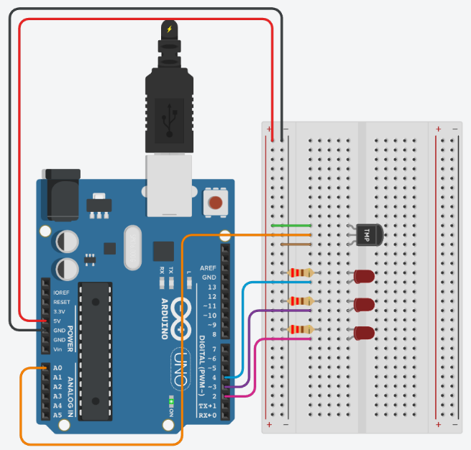
Exercise 1 Circuit
Writing the Program:

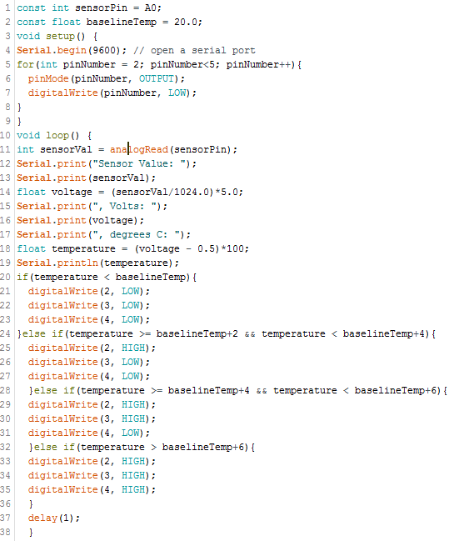
Pin A0 is used to read the voltage value coming from the temperature sensor. The constant float baselineTemp is used as a reference to compare the sensor’s temperature and determine which LED’s should be on given a certain temperature reading.

The Serial.begin(9600) command opens serial communication between the Arduino and programming computer that allows the Arduino to report values from the input pins. The number 9600 is in units of “baud” which is a unit of data transmission/reception rate.
The for loop is used to quickly set the digital pins connected to the LEDs to outputs and subsequently set each pin to LOW (LEDs are OFF) before running the program’s body. The for loop takes three arguments: the initialization, the condition, and the update. In this case, we create a temporary variable called pinNumber that acts as a counter and that we initialize as 2. This tells the for loop to begin by writing to pin 2 on the board. The condition is pinNumber < 5. This means that the loop should continue to run while the pinNumber is less than 5. The condition of a for loop is checked before each cycle to determine if the loop should run again. The update is pinNumber++. After each run of the loop, the update increments the counter variable, and the updated counter variable is checked against the condition. Without this update, the for loop would only be setting the initial pinNumber to LOW over and over again, resulting in an infinite loop which is not desired in this case.
The reason we use a for loop here is because we are doing an action over and over again i.e. setting these pins to outputs and LOW. We could write code to do this for each pin individually, but imagine if we had 50 pins to assign a mode to. This would take forever! So a for loop is great to do these repetitive actions.


The integer sensorVal is used to store the voltage value from the input pin. The temperature sensor has a resistance that varies with the temperature it detects which in turn varies the voltage received at A0. The command analogRead() maps this voltage from a 0-5V input range to a discrete value 0-1023 and stores it as sensorVal. This value between 0-1023 is then printed out to the serial monitor with Serial.print().
The voltage on the pin is then obtained by dividing sensorVal by 1024 and multiplying by 5. Finally, the temperature is obtained with the equation:
Temperature = (voltage - 0.5) * 100
This equation is derived from the temperature range (in Celsius) that the sensor is valid for as specified on the manufacturer’s data sheet. The data sheet for the TMP36 states that the temperature range it can measure within is -40ºC to 150 ºC and that a change of 10 mV is equivalent to a temperature change of 1ºC. The output voltage of the temperature sensor is between 0.1-2V. For example, the minimum output of 0.1V from the sensor should correspond to the minimum temperature specified, -40 ºC.
The Serial.println() command is similar to Serial.print(), except it creates a new line after printing the given input. This is similar to pressing ENTER on a computer keyboard and helps logically separate the printed data.

This block of code updates the LED outputs depending on the temperature reading from the sensor. Using baselineTemp as a starting point, for every 2 degrees above baselineTemp an LED will turn on. Since this is all in the void loop(), this section of code will be run over and over again, constantly updating the LEDs to reflect the temperature reading.

Introduce a small 1 millisecond delay at the end of the void loop(). The ADC can only read so fast, and if the values will appear erratic if they are read too frequently.
Using the Circuit:
To view the temperature as indicated by the temperature sensor, the Serial Monitor can be used. It will display the instantaneous readings from the circuit and can be a useful tool in troubleshooting your code. It can be accessed by selecting the magnifying glass at the top right of the Arduino program as seen below.
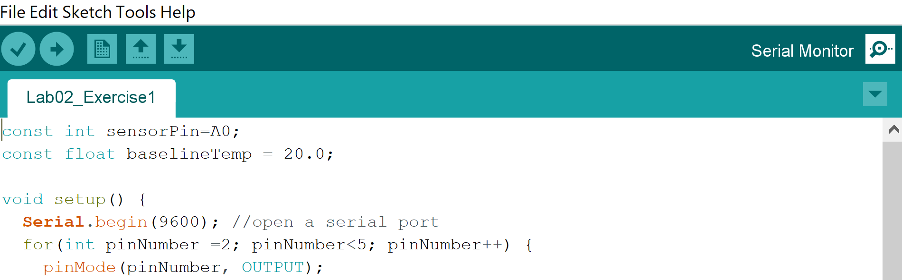

The serial monitor will report data with the headings as defined using the “Serial.print()” function in your code.
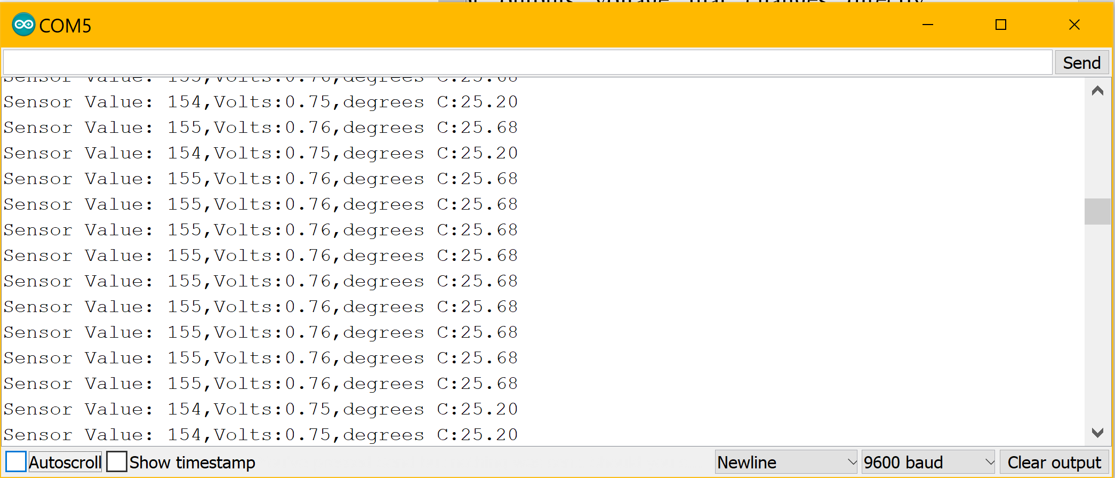

Exercise 2: Fading Between Colors of an RGB LED
You’ve already experimented with blinking LEDs, but what about fading them? You might expect that it’s just a matter of providing less voltage to an LED to get a more faded response. However, the Arduino can’t vary the output voltage on its pins. It can only output 5V. To get this fading effect, you will need to use a technique called Pulse Width Modulation (PMW). PMW rapidly turns the output pin between HIGH and LOW over a fixed period of time. The change is so quick; the human eye can’t see the flicker. The percentage of time a pin is HIGH in a period is called duty cycle, and the higher the duty cycle is, the brighter the LED appears. NOTE: The Arduino has six pins set aside for PMW: digital pins 3, 5, 6, 9, 10, and 11.
Your goal is to create a circuit with the following criteria:
- Use 3 phototransistors and assign each one to a color of the RGB LED
- Use the input from the phototransistors to create a response of the RGB LED
- The color change of the RGB LED should be smooth

Materials:
- 1 set of long red and black jumper wires
- 3 photo transistors
- 3 wooden pieces labeled E
- 1 RGB LED
- 3 light filters (1 red, 1 green, 1 blue)
- 3 10k-ohm resistors
- 3 220-ohm resistors

Building the Circuit:
- Remove USB power before tampering with the circuit
- Clear all the components from the breadboard except the lines to the power and ground buses.
- Wire your breadboard so that you receive power from both (+) buses.
- The legs of the phototransistors will fit in the hole of the small rectangular wooden pieces labeled E found in your Arduino kit. On each of these wooden pieces, there are slits where light filters (small colored plastic strips) can be placed around the phototransistor. Assemble each phototransistor with a different light filter: red, green, or blue.
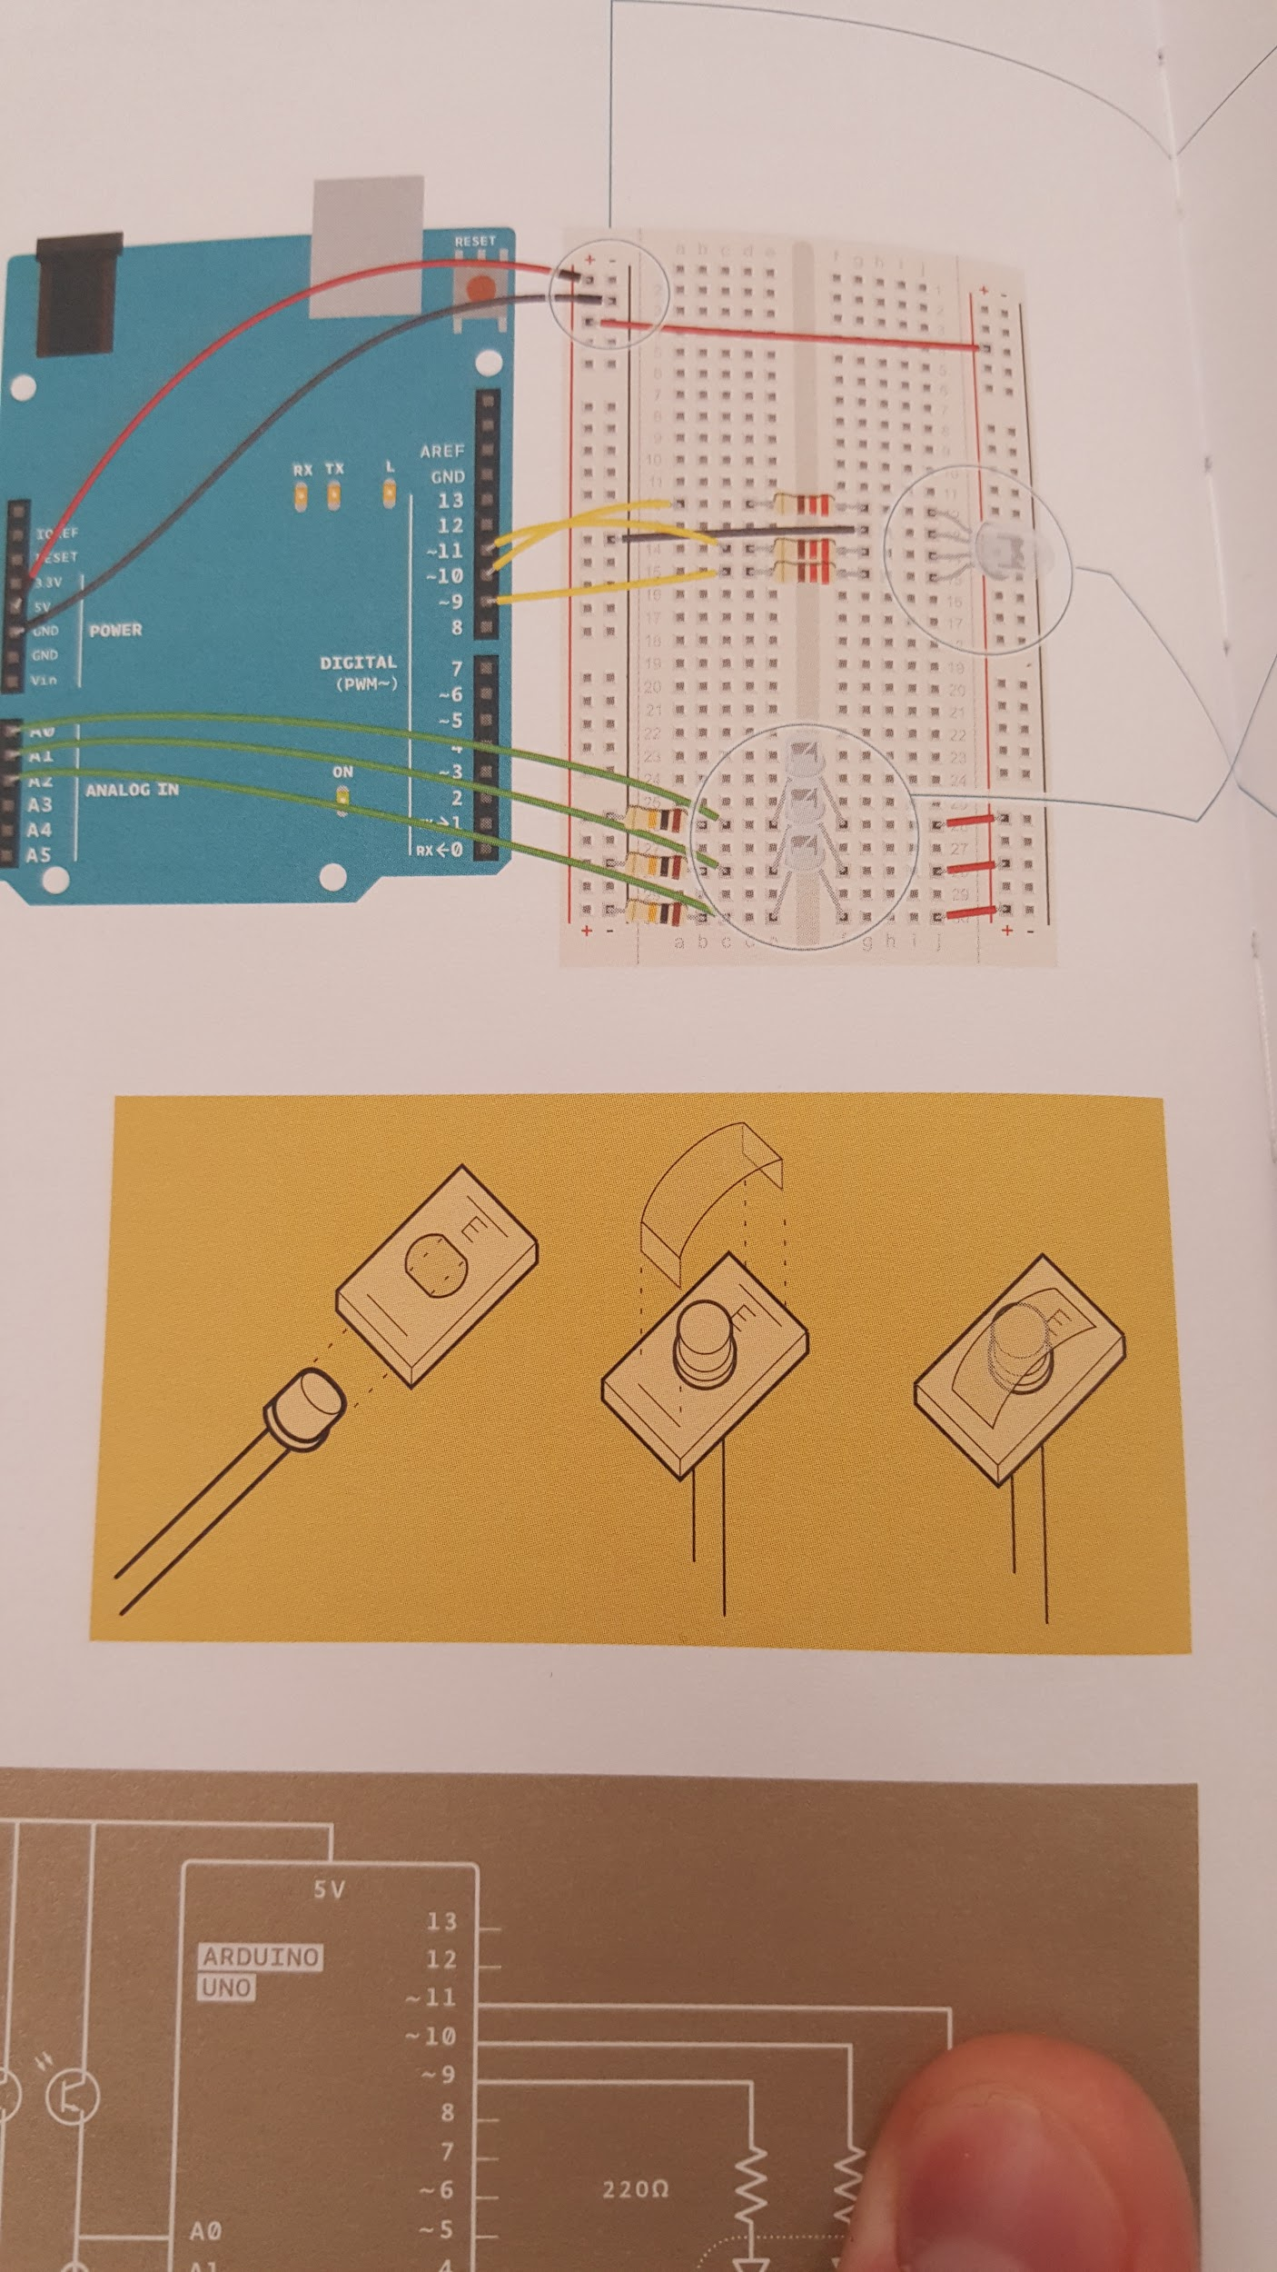
- Place the 3 phototransistors so that their legs cross the center divide from one side to the other. Wire the long leg of each phototransistor to power on the right side of the breadboard.
- On the left side of the breadboard, ground each of the short legs of the phototransistors with 10 kilohm resistors.
- Also connect the short legs of each of the phototransistors to Analog pins A0, A1, and A2 respectively
- Place the RGB LED onto the right side breadboard. The longest pin is the ground pin. Ground it to the (-) bus.
- Note which color LED the other legs are for in the figure at the top of the document. Connect each of the other pins to digital pins 9, 10, and 11 respectively, each with a 220-ohm resistor
- Plug in USB power and upload your code.

Exercise 2 Circuit

Writing the Code:

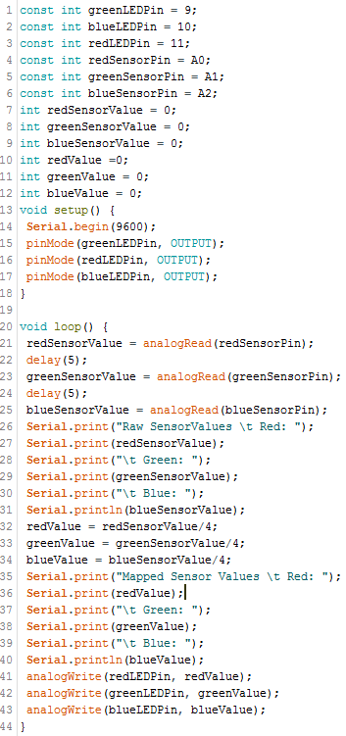
Set up constants for the pins you’re using for input and output, so you can keep track of which sensor pairs with which color on the LED. Use const for the datatype.



Initialize variables for the incoming sensor values and for the output values you’ll be sending to the pins of the LEDs. You can use the int data type for all the variables. The first three variables listed above will be the voltage read directly from each photosensor. The latter three variables will hold the numbers that will be used to tell the output pins how bright to make each LED.



In the setup, begin serial communication at 9600 baud. Just like in the previous exercise, you will use this to see the values of the sensors in the serial monitor. Additionally, you’ll be able to see the mapped values used to fade the LED. Define the Arduino pins with the LED’s connected as outputs with pinMode().



analogRead() is used again in this program this time to determine the amount of light shining on each phototransistor. The amount of voltage on the sensor input pin is proportional to the amount of light shining on each phototransistor. delay() is used here because the ADC takes a small amount of time to convert each voltage value on the pins to a number.



The values from the ADC for each sensor are printed out by the serial monitor.


The sensor values have to be divided by four because the analogRead() function outputs a range of 0-1023, but the analogWrite() function used later in the program requires a range 0-255. A value from this range determines the percentage of time that an output will be ON, which is known as duty cycle. These new mapped values are also printed.


The analogWrite() command requires a pin number to output to and a value (determined in the previous block of code) for the duty cycle of that output signal. The higher this number, the brighter that particular LED (red, green, or blue).

Using the Circuit:

Once the Arduino is programmed and powered up, open the serial monitor. The LED will probably start as an off-white color, depending on the predominant color of light in the room. Look at the values coming from the sensors. Are they consistent or fluctuating greatly?
Use the flashlight on your phone and shine it on each of the three sensors. What happens to the LED when you put the light on each one?
What does the relationship appear to be between how close the flashlight is to the sensor and how bright the light is? Linear?

Lab 2 Code Appendix (in order of appearance):

Constants (const) - A constant type is similar to a variable in that a value can be assigned to it, but this value cannot be changed throughout the rest of the code. It is used to store a reference value that will be used for comparison purposes throughout the program.

float - Unlike an integer, this type is used to store numbers with fractions, i.e. decimal numbers.
The range of values this type can store is -3.4028235E+38 to 3.4028235E+38.

Serial.begin() - This command allows the Arduino to communicate with the computer. It requires an argument which is the rate at which data will be transferred.

Serial.print() - This command is used to the tell the Arduino IDE serial monitor to print out data values coming from the Arduino board to the user.

for(initialization, condition, update or increment) - The for statement is used to repeat a block of statements enclosed in curly braces. An increment counter is usually used to increment and terminate the loop. The for statement is useful for any repetitive operation, and is often used in combination with arrays to operate on collections of data/pins.
The initialization happens first and exactly once. Each time through the loop, the condition is tested; if it’s true, the statement block, and the increment is executed, then the condition is tested again. When the condition becomes false, the loop ends.

analogRead(pin #) - This command reads the voltage level on the given pin and converts it to a discrete value between 0 and 1023 using a device called an Analog to Digital Converter (ADC).

analogWrite(pin #, duty cycle) - This command outputs a voltage level to the specified pin. The voltage level is described by a discrete value between 0 and 255. This value is used to determine the duty cycle of the PWM signal sent to an output pin.

else if() - This statement is only used following a main if statement. If the first if statement’s argument is false, then the argument of the following else if is checked. If it is true, the code within the else if statement is executed. If it is false, then the program moves to the next else if or else statement.
Else if statements are used if in a list of arguments, a programmer is only interested in taking action on one at a time. So, if one if or else if statement goes true in a list of if/else ifs, then the following else ifs are ignored by the program making for more efficient computing.

delay(time in milliseconds) - This command is used to pause a program and prevent it from updating conditions on the Arduino board for a specified amount of time. Note that the time entered is in milliseconds, not seconds.

Lab 2 Grading Rubric:
- Exercise 2 Circuit fully built. (20 points)
- Exercise #1 works (15 points)
- Exercise #2 works (15 points)
Grade distribution template (total 50 points)
- 20 points for built, but not working exercise 2 circuit.
- Exercise grade = (30 points/# of exercises) * (0, 0.5, 1) = zero, half or full exercise grade.

